EWMA correlation: EURUSD and USDJPY
Method 06 / daily log returns / lambda = 0.94 / Alpari D1 full available history

Study setup
Logical pair: EURUSD , USDJPY
Broker symbols: EURUSD_i , USDJPY_i
Snapshot: 2026-11-03_majors_alpari_D1
Timeframe: D1
Matched return window: 1999-01-05 to 2026-11-02 (UTC bar dates)
Matched return count n: 7200
Dropped unfinished last bar dated 2026-11-03 UTC after a tick-volume check against the prior complete day.
Lambda: 0.94 (today weight 0.06)
Burn-in ignored in path summaries and chart: first 60 updates
Mean adjustment: each leg demeaned by its mean on the matched rows
Seeds: c_0 = v_x,0 = v_y,0 = 0
Complete matched rows (Excel): EURUSD-USDJPY_EWMA_D1.xlsx
Complete matched rows (HTML table): EURUSD-USDJPY_EWMA_D1_data.html

Method carried forward
EWMA correlation updates covariance and variances of mean-adjusted daily log returns of close, ln(close_t / close_t-1), with lambda = 0.94 (6% weight on today's product or square, 94% on yesterday's EWMA state). Quotes are not inverted. Each leg is demeaned by its mean on the matched rows; that mean uses the full sample, so the rho path is a full-sample description, not a live filter. Seeds start at zero. Path summaries and the chart ignore the first 60 updates so the zero seed has faded. The headline is rho on the last day. rho is symmetric under swap of the two symbols. A high |rho| does not prove cause, lead-lag, or a trading signal. Today's return sits inside today's rho, so the estimate can only inform a later decision. Same-sample Pearson r is a side check only.

Results
Latest EWMA rho: -0.372335
Post-burn-in path (n=7140): mean=-0.373836, median=-0.427734, min=-0.868164, max=0.702255, std=0.277228
Share of post-burn-in days with |rho| >= 0.4: 55.18%; |rho| >= 0.7: 9.37%
Same-sample Pearson r: -0.300952
Latest rho minus r: -0.071383

Conclusion
Over 7200 matched daily log-return rows for EURUSD and USDJPY (broker quote directions unchanged), latest EWMA rho with lambda=0.94 is -0.3723 (negative, weak recent linear link in this sample). After a 60-day burn-in, path mean is -0.3738, std is 0.2772, and the range is [-0.8682, 0.7023]. Same-sample Pearson r is -0.3010 (latest rho minus r = -0.0714). This does not establish cause, lead-lag, or a lasting trading rule.

Charts
Daily closes

Daily log returns
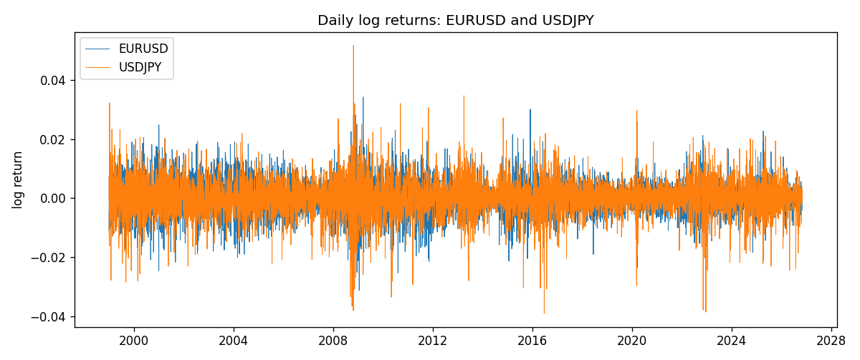
EWMA rho path with Pearson r reference
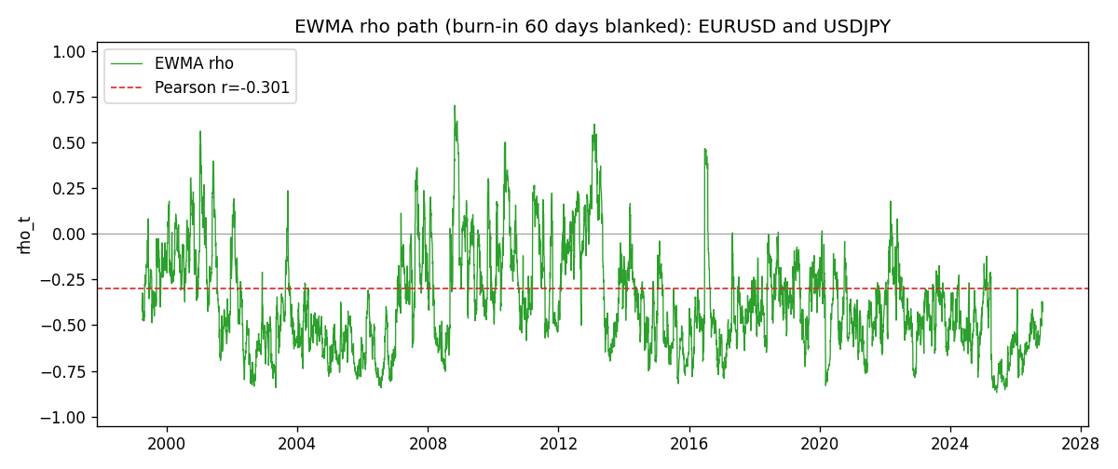

Data report
Every matched row that entered the EWMA recursion is stored in the sibling Excel workbook named EURUSD-USDJPY_EWMA_D1.xlsx. That file is the complete data archive for redrawing charts. Embedding all rows as a Word table is impractical at this length; the Word file holds the column list, column summaries, and the first and last 15 matched rows.
Columns: time, EURUSD_open, USDJPY_open, EURUSD_high, USDJPY_high, EURUSD_low, USDJPY_low, EURUSD_close, USDJPY_close, EURUSD_tick_volume, USDJPY_tick_volume, EURUSD_spread, USDJPY_spread, EURUSD_real_volume, USDJPY_real_volume, EURUSD_log_return, USDJPY_log_return, EURUSD_x_demeaned, USDJPY_y_demeaned, c_t, v_x, v_y, rho_t
Column summaries (matched calculation rows)
column | count | mean | std | min | 25% | 50% | 75% | max
EURUSD_open | 7200 | 1.1812699 | 0.15089907 | 0.8272 | 1.086045 | 1.16609 | 1.2939325 | 1.5995
USDJPY_open | 7200 | 113.80877 | 19.206548 | 75.693 | 104.4225 | 110.983 | 120.69125 | 163.824
EURUSD_high | 7200 | 1.1864006 | 0.15149686 | 0.8326 | 1.0901575 | 1.17121 | 1.2991625 | 1.6038
USDJPY_high | 7200 | 114.3063 | 19.268128 | 76.001 | 104.878 | 111.441 | 121.26 | 163.978
EURUSD_low | 7200 | 1.1762568 | 0.15022122 | 0.8227 | 1.0819775 | 1.162475 | 1.288265 | 1.5865
USDJPY_low | 7200 | 113.28572 | 19.134551 | 75.402 | 103.8875 | 110.53 | 120.17 | 163.628
EURUSD_close | 7200 | 1.1813075 | 0.15087411 | 0.8267 | 1.085995 | 1.16602 | 1.2939425 | 1.5997
USDJPY_close | 7200 | 113.82186 | 19.221964 | 75.811 | 104.4165 | 111.023 | 120.6855 | 163.851
EURUSD_tick_volume | 7200 | 103020.56 | 173417.03 | 218 | 9398.5 | 52714 | 99443.25 | 1471626
USDJPY_tick_volume | 7200 | 106139.77 | 179306.98 | 149 | 9927.5 | 53095 | 92761 | 1803508
EURUSD_spread | 7200 | 19.389444 | 16.57873 | 0 | 8 | 12 | 30 | 50
USDJPY_spread | 7200 | 20.3175 | 17.636173 | 0 | 6 | 11 | 30 | 50
EURUSD_real_volume | 7200 | 4.0252061e+10 | 1.6676396e+11 | 0 | 0 | 0 | 0 | 3.6149665e+12
USDJPY_real_volume | 7200 | 3.4708591e+10 | 1.6077621e+11 | 0 | 0 | 0 | 0 | 3.8834203e+12
EURUSD_log_return | 7200 | -1.012e-05 | 0.00580063 | -0.03123819 | -0.0032472 | 0 | 0.00325137 | 0.03433183
USDJPY_log_return | 7200 | 4.989e-05 | 0.00620383 | -0.03908203 | -0.00319719 | 0.00011638 | 0.00340925 | 0.05184024
EURUSD_x_demeaned | 7200 | -0 | 0.00580063 | -0.03122807 | -0.00323708 | 1.012e-05 | 0.00326149 | 0.03434195
USDJPY_y_demeaned | 7200 | -0 | 0.00620383 | -0.03913192 | -0.00324708 | 6.649e-05 | 0.00335936 | 0.05179035
c_t | 7200 | -1.082e-05 | 1.624e-05 | -0.00010775 | -1.793e-05 | -1.007e-05 | -4.12e-06 | 0.00020286
v_x | 7200 | 3.362e-05 | 2.63e-05 | 1.4e-06 | 1.666e-05 | 2.758e-05 | 4.241e-05 | 0.00025678
v_y | 7200 | 3.845e-05 | 3.189e-05 | 0 | 1.903e-05 | 3.088e-05 | 4.766e-05 | 0.0004123
rho_t | 7200 | -0.37245747 | 0.27799305 | -0.91522177 | -0.57482144 | -0.42585221 | -0.21154068 | 1
First 15 matched rows (selected columns)
time | EURUSD_close | USDJPY_close | EURUSD_log_return | USDJPY_log_return | EURUSD_x_demeaned | USDJPY_y_demeaned | c_t | v_x | v_y | rho_t
1999-01-05 | 1.1758 | 111.92 | -0.0048360507 | -0.00017868311 | -0.0048259312 | -0.00022857315 | 6.6184698e-08 | 1.3973767e-06 | 3.1347411e-09 | 1
1999-01-06 | 1.1623 | 112.77 | -0.011547966 | 0.0075660159 | -0.011537847 | 0.0075161258 | -5.1409809e-06 | 9.3008488e-06 | 3.3924755e-06 | -0.91522177
1999-01-07 | 1.1712 | 111.33 | 0.0076280636 | -0.012851583 | 0.007638183 | -0.012901473 | -1.0745151e-05 | 1.2243308e-05 | 1.3175807e-05 | -0.84600807
1999-01-08 | 1.1585 | 110.8 | -0.010902799 | -0.0047719894 | -0.01089268 | -0.0048218795 | -6.9490501e-06 | 1.8627738e-05 | 1.378029e-05 | -0.43372675
1999-01-11 | 1.1503 | 109.02 | -0.007103287 | -0.016195423 | -0.0070931675 | -0.016245313 | 3.8173636e-07 | 2.0528856e-05 | 2.8788083e-05 | 0.015702716
1999-01-12 | 1.1555 | 112.6 | 0.0045103728 | 0.032310364 | 0.0045204922 | 0.032260474 | 9.1088255e-06 | 2.0523215e-05 | 8.9505089e-05 | 0.21252784
1999-01-13 | 1.1681 | 113.52 | 0.010845346 | 0.0081373171 | 0.010855466 | 0.0080874271 | 1.3829863e-05 | 2.6362291e-05 | 8.8059173e-05 | 0.28703775
1999-01-14 | 1.1681 | 113.52 | 0 | 0 | 1.0119423e-05 | -4.9890045e-05 | 1.3000041e-05 | 2.4780559e-05 | 8.2775772e-05 | 0.28703679
1999-01-15 | 1.1563 | 114.15 | -0.010153245 | 0.0055343401 | -0.010143126 | 0.0054844501 | 8.8822708e-06 | 2.9466706e-05 | 7.9613977e-05 | 0.18338489
1999-01-18 | 1.1605 | 114.16 | 0.0036256946 | 8.7600193e-05 | 0.003635814 | 3.7710148e-05 | 8.357561e-06 | 2.8491852e-05 | 7.4837224e-05 | 0.18099242
1999-01-19 | 1.1603 | 113.52 | -0.00017235436 | -0.0056219403 | -0.00016223494 | -0.0056718304 | 7.9113175e-06 | 2.678392e-05 | 7.227717e-05 | 0.1798089
1999-01-20 | 1.1566 | 112.91 | -0.0031939256 | -0.0053879917 | -0.0031838062 | -0.0054378817 | 8.4754281e-06 | 2.5785082e-05 | 6.9714773e-05 | 0.199901
1999-01-21 | 1.1601 | 113.87 | 0.0030215416 | 0.0084664056 | 0.003031661 | 0.0084165156 | 9.4978637e-06 | 2.4789435e-05 | 6.9782151e-05 | 0.22836021
1999-01-22 | 1.1587 | 114.56 | -0.0012075213 | 0.0060412564 | -0.0011974019 | 0.0059913663 | 8.4975475e-06 | 2.3388095e-05 | 6.774901e-05 | 0.21347386
1999-01-25 | 1.1552 | 113.72 | -0.0030251979 | -0.0073594164 | -0.0030150784 | -0.0074093065 | 9.3280731e-06 | 2.2530252e-05 | 6.6977939e-05 | 0.24012813
Last 15 matched rows (selected columns)
time | EURUSD_close | USDJPY_close | EURUSD_log_return | USDJPY_log_return | EURUSD_x_demeaned | USDJPY_y_demeaned | c_t | v_x | v_y | rho_t
2026-10-13 | 1.11965 | 158.305 | 0.0037402957 | -0.0018932826 | 0.0037504151 | -0.0019431726 | -7.0524551e-06 | 1.0562052e-05 | 1.9769501e-05 | -0.48805451
2026-10-14 | 1.11545 | 158.317 | -0.0037582255 | 7.5800166e-05 | -0.0037481061 | 2.5910121e-05 | -6.6351347e-06 | 1.0771227e-05 | 1.8583371e-05 | -0.46898063
2026-10-15 | 1.12172 | 158.024 | 0.0056053107 | -0.0018524319 | 0.0056154301 | -0.001902322 | -6.8779679e-06 | 1.2016936e-05 | 1.7685499e-05 | -0.47179639
2026-10-16 | 1.12371 | 157.964 | 0.0017724895 | -0.00037976126 | 0.0017826089 | -0.00042965131 | -6.5112439e-06 | 1.1486582e-05 | 1.6635445e-05 | -0.47103301
2026-10-19 | 1.12086 | 158.517 | -0.0025394633 | 0.0034946841 | -0.0025293438 | 0.0034447941 | -6.6433534e-06 | 1.1181242e-05 | 1.6349314e-05 | -0.49135181
2026-10-20 | 1.12354 | 158.16 | 0.0023881672 | -0.0022546642 | 0.0023982867 | -0.0023045543 | -6.5763711e-06 | 1.0855474e-05 | 1.5687014e-05 | -0.50395502
2026-10-21 | 1.12318 | 158.108 | -0.00032046717 | -0.00032883504 | -0.00031034775 | -0.00037872509 | -6.1747366e-06 | 1.0209925e-05 | 1.4754399e-05 | -0.50309084
2026-10-22 | 1.12139 | 156.755 | -0.0015949606 | -0.0085942669 | -0.0015848412 | -0.0086441569 | -4.9822755e-06 | 9.7480324e-06 | 1.8352422e-05 | -0.37249681
2026-10-23 | 1.11989 | 156.81 | -0.001338521 | 0.00035080446 | -0.0013284016 | 0.00030091442 | -4.707323e-06 | 9.2690295e-06 | 1.725671e-05 | -0.37220129
2026-10-26 | 1.11735 | 157.458 | -0.0022706559 | 0.0041238746 | -0.0022605365 | 0.0040739846 | -4.9774471e-06 | 9.0194892e-06 | 1.7217148e-05 | -0.39942485
2026-10-27 | 1.11272 | 157.894 | -0.004152342 | 0.0027651658 | -0.0041422226 | 0.0027152757 | -5.3536369e-06 | 9.5078004e-06 | 1.6626482e-05 | -0.42580298
2026-10-28 | 1.1152 | 157.743 | 0.0022262927 | -0.00095679538 | 0.0022364121 | -0.0010066854 | -5.1675005e-06 | 9.2374247e-06 | 1.5689698e-05 | -0.42923761
2026-10-29 | 1.11772 | 157.683 | 0.0022571351 | -0.00038043789 | 0.0022672545 | -0.00043032793 | -4.9159902e-06 | 8.9916058e-06 | 1.4759427e-05 | -0.42673437
2026-10-30 | 1.11644 | 157.516 | -0.0011458446 | -0.0010596481 | -0.0011357252 | -0.0011095382 | -4.545423e-06 | 8.5295018e-06 | 1.3947726e-05 | -0.41673575
2026-11-02 | 1.11881 | 157.933 | 0.002120569 | 0.0026438521 | 0.0021306884 | 0.002593962 | -3.9410821e-06 | 8.2901216e-06 | 1.3514581e-05 | -0.37233489

